# TAKING STOCK OF THE APORTA 2023 INITIATIVE

**One more year, boosting open data in Spain**

## 1) [SPAIN CONTINUES TO PERFORM WELL IN INTERNATIONAL INDICES](https://datos.gob.es/en/noticia/spain-among-european-leaders-open-data)

Spain, among the leaders in open data according to the OECD and the European Data Portal.

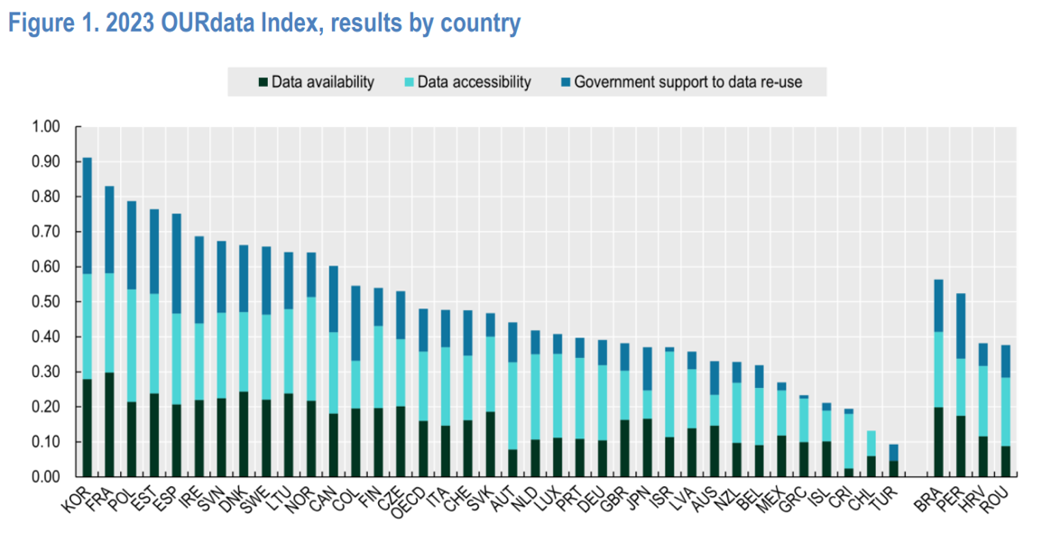

Fuente: OURdata Index, OCDE, 2023

# 2) DATOS.GOB.ES CONSOLIDATES ITS POSITION AS SPAIN'S MEETING POINT FOR OPEN DATA

|  |  |
| --- | --- |
| Interfaz de usuario web datos.gob.es | **+ 1.7 million visits in 2023**  **21% growth compared to 2022**  Every day more and more users join our social networks to keep up to date with news and trends related to data-driven innovation. |

|  |  |  |  |
| --- | --- | --- | --- |
| Logo X | **20.700 followers** (+6 % growth over 2022) | Logo linkedin | **9.000 followers** (+52 % growth over 2022) |
| **15.000 interactions** | **17.500 interactions** |

**ARTIFICIAL INTELLIGENCE** OPEN DATA DATA SHARING **HACKATHONS** **DATA SPACES   
GOVERNANCE** ALGORITHMS MACHINE LEARNING **GAIA-X** NLP **SUCCESS STORIES** **HIGH-VALUE DATA** QUALITY **NORMALIZATION REGULATION** **STANDARISATION** TRAINING **GPT CHAT**

# 3) THE NATIONAL CATALOGUE CONTINUES TO GROW

**+ 76.000 Datasets published in the National Catalogue**

**19% growth compared to 2022**

Specifically, in 2023 it has been increased:

|  |  |  |  |  |
| --- | --- | --- | --- | --- |
| **+1,200**  **new datasets published on a variety of topics** | **+85,000**  **Distributions** (new files in different formats for easy re-use) | **+77**  **publishing agencies  at all levels of government** | **+400**  **user comments to the published datasets** | **+30**  **requests for new datasets to be published** |

Throughout the year, surveys of new datasets and audits of published metadata have been carried out in order to boost their quality and reusability

# 4) DRIVING THE DATA CULTURE

**During 2023 we have published new content to boost the acquisition of skills related   
to data analysis and processing:**

### 100 NEW ARTICLES IN THE BLOG AND NEWS SECTIONS

|  |  |
| --- | --- |
| **To stay updated in technologies related to data and the evolution of the open data.** | * [Chat GPT-3: programming a data visualisation in R](https://datos.gob.es/en/blog/gpt-3-chat-we-programmed-data-visualisation-r-trending-ai) * [How to choose the right graph for visualising open data](https://datos.gob.es/en/blog/how-choose-right-chart-visualise-open-data) * [Dall-e: NPL and AI on images](https://datos.gob.es/en/blog/dall-e-nlp-and-ai-images) * [Europe defines high-value datasets](https://datos.gob.es/en/noticia/europe-defines-high-value-datasets-public-sector-will-have-open-2024-latest) * [UNE 0081 Specification - Data Quality Assessment Guide](https://datos.gob.es/en/blog/une-0081-specification-data-quality-assessment-guide) * [Emerging trends in geospatial data and AI](https://datos.gob.es/en/blog/emerging-trends-geospatial-data-and-ai) |

**NEW PRACTICAL EXERCISES**

|  |  |  |
| --- | --- | --- |
| **Gráfico Análisis de datos meteorológicos con la librería “ggplot2”** | **Gráfico  Generación de mapas con “Google My Maps”** | **Gráfico Análisis de redes** |
| [Meteorological data analysis with the "ggplot2" library](https://datos.gob.es/en/documentacion/analysis-meteorological-data-using-ggplot2-library) | [Map generation with "Google My Maps"](https://datos.gob.es/en/documentacion/generating-personalized-tourist-map-google-my-maps) | [Network analysis](https://datos.gob.es/en/documentacion/analysis-travel-networks-bicimad) |

Code available on GitHub

**NEW GUIDES AND REPORTS**

* [Summary data:](https://datos.gob.es/es/documentacion/datos-sinteticos-que-son-y-para-que-se-usan) [what are they and what are they used for?](https://datos.gob.es/en/documentacion/synthetic-data-what-are-they-and-what-are-they-used)
* [Good practices for measuring the impact of open data](https://datos.gob.es/en/documentacion/good-practices-measuring-impact-open-data-europe)
* [Open data and re-use in the judicial field](https://datos.gob.es/en/documentacion/open-data-and-reuse-public-sector-information-judicial-field-challenges-regulation-use)

**NEW USE CASES TO INSPIRE YOU**

|  |  |
| --- | --- |
| **Companies** 88 examples of data-driven business en datos (+12) | **Aplications** 433 examples of solutions developed using open data (+28) |

+ And much more...

|  |  |
| --- | --- |
| **WITH MORE VISUAL CONTENT: NEW INFOGRAPHICS AND VIDEOS**   * UNE Specifications * Synthetic Data * Artificial Intelligence and Open Data * Open Education Data: Examples of Reuse * Open Data for the Construction of Sustainable Cities * Regulation Regarding Open Data in Spain   And much more… | Ejemplo de infografia |

# 5) WE ADVISE PUBLIC ADMINISTRATIONS

|  |  |
| --- | --- |
| Served more than **600** consultations of **140** public institutions and carried out **30** virtual expert support sessions. | * We assist in the publication of data in the National Catalogue * We ensure the quality of metadata that facilitates your search * We guide agencies in the implementation of open data strategies |

**thank you all for a great year!**

In 2024 we will continue to make progress in the management, sharing and  
use of data in the Spanish economy and society.