The impact of open data globally
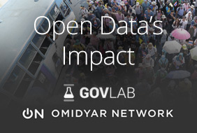
Public entities, private bodies, civil organizations and citizens are increasingly realising that there are many socioeconomic benefits from opening data. Despite this, there are much to discover about the re-use of public sector information. Nowadays, systematic studies that assess open data’s impact are still lacking. The field is dominated by conjectural estimates of open data’s hypothetical impact instead of real-world examples.
The GovLab, in collaboration with Omidyar Network, has worked to build a repository of 19 detailed open data case studies from around the world. The 19 of them will be exhaustively analysed to assess open data’s impact. Thus, the Open Data’s Impact repository, still in beta, seeks to:
- Offer a more rigorous analysis of the processes and factors underlying the demand, supply, release, use and impact of open data.
- Assess and provide evidence for the premise that open data has the potential to impact society.
- Provide actionable insights to policymakers, civil society representatives, entrepreneurs, researchers and others interested in re-using open data.
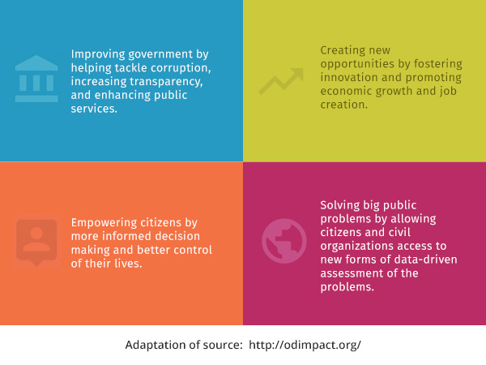
The Open Data’s Impact is built in part from secondary sources like news reports and academic papers and also from more than 60 first-hand interviews with important players from open data sector. In this way, the case studies seek to go beyond the descriptive and they explain why and how they impact in their environment.
In order to provide these explanations, an analytical framework has been assembled. This framework allows to outline the necessary conditions for the open data to be effective, identify the challenges faced by open data projects and establish a taxonomy of impact for open data according to various dimensions.
To date, The GovLab has shared thirteen cases studies regarding two of the four impact dimensions: improving government and empowering citizens. This first batch shows how open data is leading to the discovery of tax fraud among charities in Canada; the reduction among public officials in Brazil; more transparency of the voting process in Indonesia or more informed decision-making regarding health care by citizens in Uruguay.
In February twelve additional case studies will be released to solving public problems and creating economic opportunity. In March, the paper will also include a set of recommendations to help the open data community to achieve maximum impact of the re-use of public sector information.

Tags: Open Data’s Impact, reuse of public sector information, The GovLab,

